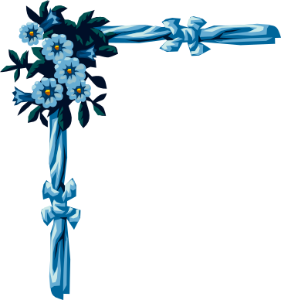
PRESENT TIME CLAUSES

[main clause] May always takes a shower before she goes to bed. [time clause]
[USE: simple present tense] [USE: simple present tense]
--OR--
[time clause] Before May goes to bed, she always takes a shower. [main clause]
[USE: simple present tense] comma -> , [USE: simple present tense]

Write the correct forms of the verbs to complete these present time clauses. And complete with before, after or when.

First: May washes the dishes. Then: May watches TV. (usually)
- May usually (wash) ___________ the dishes before she (watch) ___________ TV.
- Before May (watch) ___________ TV, she usually (wash) ___________ the dishes.

First: May brushes her teeth. Then: May eats a snack. (seldom)
- May seldom (eat) ___________ a snack after she (brush) ___________ her teeth.
- After May (brush) ___________ her teeth, she seldom (eat) ___________ a snack.

First: May sleeps on her back. And: May snores loudly! (always)
- May always (snore) ___________ loudly when she (sleep) ___________ on her back!
- When May (sleep) ___________ on her back, she always (snore) ___________ loudly!

First: May writes an essay. And: May makes mistakes. (sometimes)
- May sometimes (make) ___________ mistakes when she (write) ___________ an essay.
- When May (write) ___________ an essay, she sometimes (make) ___________ mistakes.

First: May rides her bicycle to school. Then: May whistles songs. (occasionally)
- May occasionally (whistle) ___________ songs as she (ride) ___________ her bicycle to school.
- As May (ride) ___________ her bicycle to school, she occasionally (whistle) ___________ songs.

PRESENT TIME CLAUSES

[main clause] May always takes a shower before she goes to bed. [time clause]
[USE: simple present tense] [USE: simple present tense]
--OR--
[time clause] Before May goes to bed, she always takes a shower. [main clause]
[USE: simple present tense] comma -> , [USE: simple present tense]

Write the correct forms of the verbs to complete these present time clauses.

First: May washes the dishes. Then: May watches TV. (usually)
- May usually (wash) ___________ the dishes before she (watch) ___________ TV.
- Before May (watch) ___________ TV, she usually (wash) ___________ the dishes.

First: May brushes her teeth. Then: May eats a snack. (seldom)
- May seldom (eat) ___________ a snack after she (brush) ___________ her teeth.
- After May (brush) ___________ her teeth, she seldom (eat) ___________ a snack.

First: May sleeps on her back. And: May snores loudly! (always)
- May always (snore) ___________ loudly when she (sleep) ___________ on her back!
- When May (sleep) ___________ on her back, she always (snore) ___________ loudly!

First: May writes an essay. And: May makes mistakes. (sometimes)
- May sometimes (make) ___________ mistakes when she (write) ___________ an essay.
- When May (write) ___________ an essay, she sometimes (make) ___________ mistakes.

First: May rides her bicycle to school. Then: May whistles songs. (occasionally)
- May occasionally (whistle) ___________ songs as she (ride) ___________ her bicycle to school.
- As May (ride) ___________ her bicycle to school, she occasionally (whistle) ___________ songs.

